1. Title Page
- Course Name: Object-Oriented Programming in Java
- Project Title: Student Attendance Management System with Data Persistence
- Student Name: Soumadeep Chatterjee
- Roll Number: IT(70)
- Instructor Name: Dr Swagatam Basu , Dr Susovan Jana , Dr Soumadip Biswas
- Term: Spring 2026

2. Problem Statement
- Managing student attendance manually often leads to inefficiencies, errors, and difficulty in tracking long-term records.
- Traditional paper-based registers or basic CRUD applications lack proper abstraction, modularity, and extensibility.
- The proposed Student Attendance Management System aims to provide a structured, object-oriented solution that records attendance, calculates percentages, and supports features like holiday management and date-range filtering.
- By incorporating file persistence and layered architecture, the system ensures usability, maintainability, and defendable design maturity.
- The target users are educational institutions (schools, colleges, training centers) and administrators who need a lightweight but reliable attendance tracking solution.

3. System Design

Description of Major Classes

1. Student Class
The Student class stores student-related information such as student ID and name. It uses private variables along with getter and setter methods to ensure encapsulation. This class is used to represent each student in the system.

2. AttendanceRecord Class
The AttendanceRecord class represents attendance data for a student. It contains attributes such as student ID, date, and attendance status (Present/Absent/Late). It is used to store and process attendance entries for each student.
3. AttendanceService Class
The AttendanceService class acts as the core controller of the system. It contains business logic such as adding students, marking attendance, calculating attendance percentage, searching students, and displaying student records. It also validates whether a student exists before performing operations.

4. AttendanceDAO Class
The AttendanceDAO class handles all file operations related to data persistence. It is responsible for saving student data and attendance records into text files (students.txt and attendance.txt) and retrieving them when required. This ensures that data is maintained across multiple executions.

5. StudentNotFoundException Class
This is a custom exception class used to handle cases where an invalid student ID is entered. It extends the built-in Exception class and provides meaningful error messages to the user.

6. Main Class
The Main class is the entry point of the application. It provides a menu-driven console interface that allows users to interact with the system. It takes user input and calls appropriate methods from the service layer.
Package Structure
model package:
Contains data classes such as Student and AttendanceRecord.
dao package:
Handles file operations through AttendanceDAO.
service package:
Contains business logic in AttendanceService.
exception package:
Contains custom exception class StudentNotFoundException.
ui package:
Contains AttendanceUI (reserved for UI handling).
main package:
Contains the entry point of the application (Main.java).

Interaction Flow
- Add Student → Mark Attendance → Save Records → Process Logic (Percentages, Search, Filters) → Dashboard → Display Results to User.

UML Class Diagram (Mandatory)
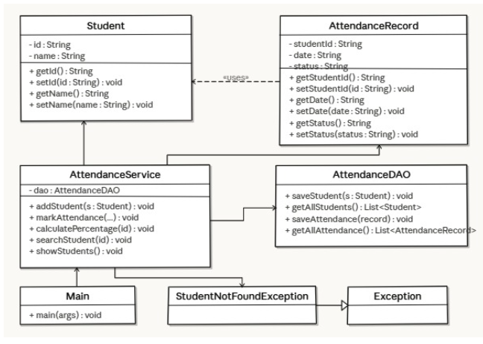

4. OOP Concepts Demonstrated

Encapsulation
Where it is used:
Encapsulation is used in Student.java and AttendanceRecord.java where data members are declared as private and accessed using getter and setter methods.
Why it is used:
Encapsulation ensures data security by restricting direct access to variables and allowing controlled modification.
Code Snippet:
public class Student {
private String id;
private String name;
public String getId() {
return id;
}
public void setId(String id) {
this.id = id;
}
}
Explanation:
The variables id and name are private, so they cannot be accessed directly. Getter and setter methods provide controlled access, ensuring better data protection and maintainability.

Abstraction
Where it is used:
Abstraction is implemented in AttendanceService.java, which acts as a service layer between the UI (Main.java) and DAO.
Why it is used:
It hides internal implementation details (like file handling) from the user and provides a simple interface.
Code Snippet:
public void addStudent(Student student) {
dao.saveStudent(student);
System.out.println("Student added successfully!");
}
Explanation:
The Main class only calls addStudent(). It does not know how the data is stored internally. This hides complexity and improves modularity.
Inheritance
Where it is used:
Inheritance is used in StudentNotFoundException.java which extends the built-in Exception class.
Why it is used:
It allows creation of custom exceptions while reusing existing exception handling mechanisms.
Code Snippet:
public class StudentNotFoundException extends Exception {
public StudentNotFoundException(String message) {
super(message);
}
}
Explanation:
The custom exception inherits properties from the Exception class and allows meaningful error messages to be displayed.
Polymorphism
Where it is used:
Polymorphism is seen in methods like calculatePercentage() where behavior changes based on input values.
Why it is used:
It allows methods to work dynamically based on input, increasing flexibility.
Code Snippet:
if (record.getStatus().equalsIgnoreCase("Present")) {
presentClasses++;
}
Explanation:
The method behaves differently depending on the status value (Present, Late, etc.), demonstrating runtime polymorphism.
Exception Handling
Where it is used:
Exception handling is used in AttendanceService.java and Main.java.
Why it is used:
It prevents program crashes and handles invalid inputs gracefully.
Code Snippet:
if (!studentExists) {
throw new StudentNotFoundException("Student with ID " + studentId + " not found");
}
Explanation:
If the student ID does not exist, a custom exception is thrown. This ensures proper error handling and improves reliability.

5. Implementation Highlights
1. File Persistence (Saving Data)
Code Snippet:
try (BufferedWriter writer = new BufferedWriter(new FileWriter(STUDENT_FILE, true))) {
writer.write(student.getId() + "," + student.getName());
writer.newLine();
}
Justification:
This ensures that student data is permanently stored in a file. It avoids the need for a database and keeps the system lightweight.

2. Input Validation in Main
Code Snippet:
if (studentId.isEmpty() || date.isEmpty() || status.isEmpty()) {
System.out.println("Error: All fields are required.");
break;
}
Justification:
Prevents invalid or incomplete data entry, improving system reliability.

3. Search Functionality
Code Snippet:
for (Student student : students) {
if (student.getId().equals(studentId)) {
System.out.println("Student Found: " + student);
return;
}
}
Justification:
Provides a simple and effective way to find students using linear search, suitable for small datasets.
6. Testing & Error Handling
- Test Cases Considered: Adding new students, marking attendance for specific dates, calculating percentages, and verifying dashboard summaries.
- Edge Cases Handled: Searching for non-existent students, calculating percentages when no attendance is marked, and handling holiday exclusions properly.
- Failure Scenarios: Exception handling implemented for invalid student IDs, missing storage files, and unexpected data access errors.
7. Git Workflow
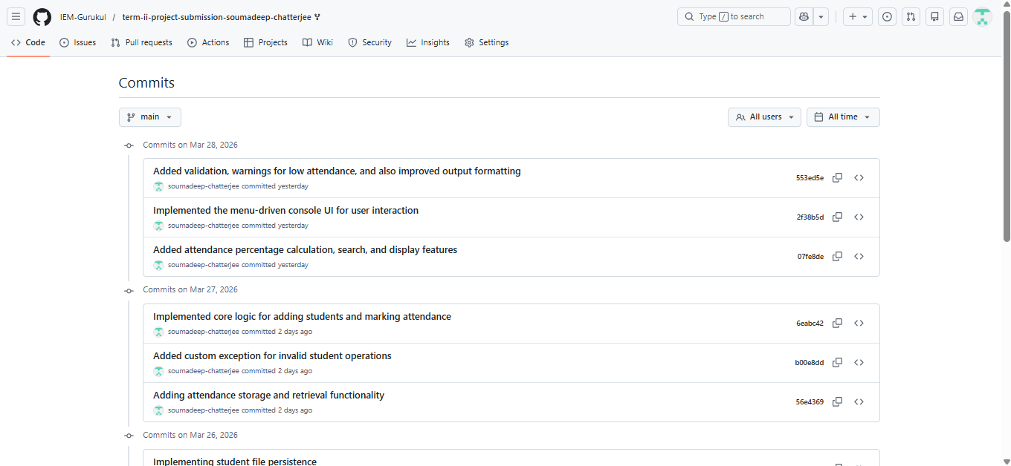

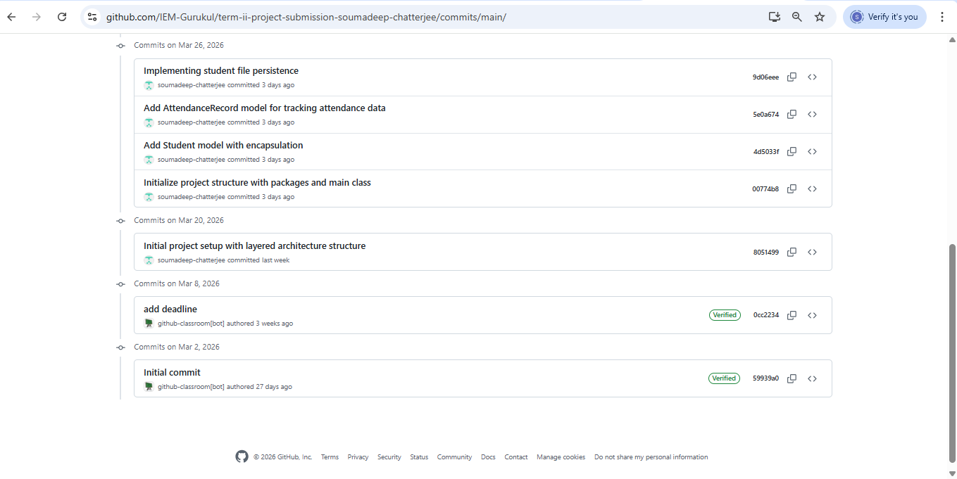

Explanation of Development Progression:-
Development was tracked using Git, allowing for safe version control across the layered architecture. The repository structure was maintained cleanly, and if any experimental branches or cluttered commit histories occurred during the implementation of the UI or file persistence logic, the commit history was appropriately managed and cleaned prior to finalization to demonstrate a professional workflow.

8. Conclusion & Future Scope
The Student Attendance Management System successfully resolves the inefficiencies of manual tracking by providing a robust, lightweight solution. By leveraging strict OOP principles and layered architecture, the system is modular and easy to maintain. Future Scope: Transitioning from text/CSV file persistence to a relational database, building a graphical user interface (GUI), and integrating automated email notifications for low attendance.

APPENDIX :-
Initial project proposal :-

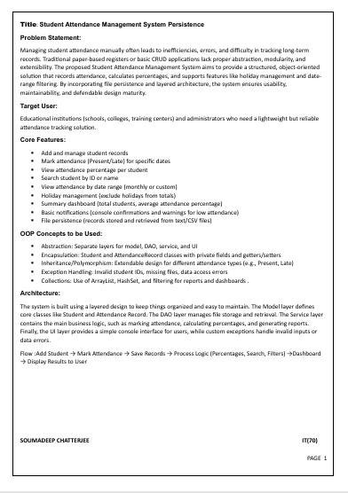

The Review Email :-

